EMCEES

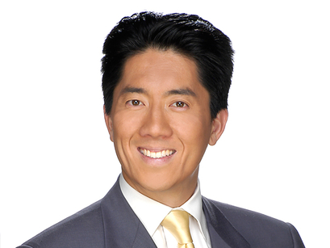
Ted Chen
KNBC 4

Ted Chen is the anchor of the Saturday edition of "Today in LA" and also anchors the new program “Sunday LA” on NBC4’s Digital Channel 4.2. He is also a general assignment reporter for the "Channel 4 News."
Since joining the award-winning NBC4 Los Angeles in 1995, Chen has reported on many major news stories. He covered the 2008 Summer Olympics in Beijing China, reporting live on the gold-medal winning accomplishments of Team USA as well as the impact of economic transformation in a country of more than one billion people.
In 2004 and 2005, Chen covered the Scott Peterson Trial in Redwood City, California. A journalist with a diverse array of skills, Chen has also covered such Hollywood events as the Academy Awards, Golden Globes and Emmy Awards.
In addition to his duties at NBC4, Chen is also a fill-in host on 89.3, KPCC, Southern California Public Radio. As a substitute host for Larry Mantle and Pat Morrison, he interviews newsmakers on a local, state and National level.
Chen came to NBC4 from KGTV in San Diego, where he began in 1993 as a general assignment reporter and substitute anchor for the weekday morning and weekend newscasts.
In 2002, Chen was honored by the Columbia Graduate School of Journalism’s Workshop on Journalism, Race & Ethnicity, for his series of news stories on Asian Americans. The pieces dealt with Asian American political power, the role of Chinese schools in shaping Chinese American children, and the forgotten heroics of Chinese American World War II veterans.
Chen is a member of the Board of Directors for the Chinese American Museum in Los Angeles and regularly serves as master of ceremonies for many community events in Los Angeles and throughout the San Gabriel Valley.
Chen began his career in 1990 as a production and writer’s assistant at KCAL-TV in Los Angeles. He attended the University of California at Los Angeles, and graduated from the University of California in San Diego with a Bachelor of Arts degree in political science.

